Academic Year: 2025-26 | Year: Second Year | Semester: II
PRN No.: 1012411011 | Name: Riddhee Kulkarni
Subject: Python Programming
Assignment No.: 5
Date: 29/12/2025

Lab Assignment: 05
Aim:
To write a Python program to calculate the total bill amount of an item based on quantity sold, price per item, discount percentage, and tax percentage.

Objective:
- To understand bill calculation logic using arithmetic operations.
- To apply discount and tax percentages in a Python program.
- To practice user input handling and output display in Python.
- To calculate the final payable bill amount accurately.

Theory:
In billing systems, the gross amount is calculated by multiplying quantity with price per item.
A discount is applied as a percentage of the gross amount and subtracted from it.
Tax is then calculated on the discounted amount.
Python allows easy calculation of such values using arithmetic operators and user input functions.

Algorithm:
- Start the program.
- Input quantity sold.
- Input price per item.
- Input discount percentage.
- Input tax percentage.
- Calculate gross amount.
- Calculate discount amount.
- Subtract discount from gross amount.
- Calculate tax on the discounted amount.
- Add tax to get the final bill amount.
- Display the total bill amount.
- Stop the program.

Pseudo Code:
START
READ quantity
READ price
READ discount_percent
READ tax_percent
gross_amount ← quantity × price
discount ← (discount_percent / 100) × gross_amount
net_amount ← gross_amount – discount
tax ← (tax_percent / 100) × net_amount
total_bill ← net_amount + taxDISPLAY total_billEND

Code:
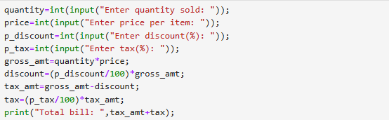

Output:
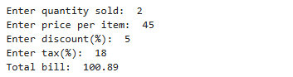

Conclusion:
The program successfully calculates the final bill amount by applying discount and tax to the gross amount. It demonstrates the use of arithmetic operations, percentage calculations, and user input handling in Python. This program helps understand real-world billing calculations using programming concepts.

